**N4DAC02 modbus rtu protocol**

**Function code**

|  |  |  |  |  |
| --- | --- | --- | --- | --- |
| RS485 address  (Station address)  (1) | Function (1) | Register address (2) | Read number (2) | CRC16 (2) |
|  | 03 Read |  |  |  |
|  | 06 Write |  |  |  |

|  |  |  |  |  |
| --- | --- | --- | --- | --- |
| Read-only register,Read Function code Is 03 | | | | |
| Register address | Register contents | Number of bytes | Units | Remarks |
| 0x0000 | (CH1)O1 Voltage value | 2 | 0.01V | such as:  Input 0x00C8  Decimal 200  Output= 200 * 0.01 = 2.00V |
| 0x0001 | (CH2)O2 Voltage value |
| Read / write register; Read function code is 03 ,Write function code is 06 | | | | |
| 0x0007 | (CH1)O1 Voltage ratio | 2 | 0.1%  millesimal | This value can be corrected when the Actual output voltage is greater than 1%, such as:  1000 means 1:1  1010: 1% increase  990: 1% decrease |
| 0x0008 | (CH2)O2 Voltage ratio |
| 0x000E | RS485 address  (Station address) | 2 |  | Read Address 0XFF  Write Address 1-247 |
| 0x000F | Baud rate | 2 |  | 0~4 0:1200  1:2400 2:4800  3:9600（default）  4:19200  5: Factory reset |

**Serial baud rate：9600（**default**），N，8，1**

**Modbus RTU Communication protocol：**

Read the output voltage value of channel 1/2, the unit is 0.01V

1. **Read Voltage value**

Send data

|  |  |  |  |  |
| --- | --- | --- | --- | --- |
| RS485 address  (Station address)  (1) | Function (1) | Register address (2) | Read number (2) | CRC16(2) |

Returns data

|  |  |  |  |  |
| --- | --- | --- | --- | --- |
| RS485 address  (Station address)  (1) | Function (1) | Number of bytes (1) | data (n) | CRC16(2) |

RS485 address(Slave ID) : 0x01~0xFE

Function code 0x03

Register address：0x0000-0x0001, Indicates 1-2channel value

Read number：0x0001-0x0002

For example:

Send data(RS485 address is 1)：01 03 00 00 00 01 84 0A ;00 means channel 1

Returns data：01 03 02 00 C8 B9 D2

01 RS485 address,03 Function,02 length,B9 D2 crc16

00C8 is the Output voltage value, it is converted to decimal = 200, 200/100=2.00V；

For example:

Send data(RS485 address is 1)：01 03 00 01 00 01 D5 CA ;01 means channel 2

Returns data：01 03 02 01 F4 B8 53

01 RS485 address,03 Function,02 length, B8 53 crc16

01F4 is the Output voltage value, it is converted to decimal = 500, 500/100=5.00V；

1. **Set Output Voltage value**

Set the output voltage value of channel 1/2, the unit is 0.01VSend data

|  |  |  |  |  |
| --- | --- | --- | --- | --- |
| RS485 address  (Station address)  (1) | Function (1) | Register address (2) | Setting Content (2) | CRC16(2) |

Returns data

|  |  |  |  |  |
| --- | --- | --- | --- | --- |
| RS485 address  (Station address)  (1) | Function (1) | Register address  (2) | Register value (2) | CRC16(2) |

RS485 address(Slave ID) : 0x01~0xFE

Function code 0x06

Register address：0x0000-0x0001; Indicates 1-2 channel value

Setting value: 2 bytes, unit 0.01V. The voltage range set for channel 1 is 0.05-5V, and the voltage range set for channel 2 is 0.10-10V.

For example 1: Let CH1 output 3.3V voltage. Input value 330 and convert it to hexadecimal 014A

Send frame: 01 06 00 00 01 4A 09 AD

Return frame: 01 06 00 00 01 4A 09 AD

For example 2: Let CH2 output 4V voltage. Input value 400 and convert it to hexadecimal 0190

Send frame: 01 06 00 00 01 90 88 36

Return frame: 01 06 00 00 01 90 88 36

1. **Read Voltage ratio:**

Send data

|  |  |  |  |  |
| --- | --- | --- | --- | --- |
| RS485 address  (Station address)  (1) | Function (1) | Register address (2) | Read number (2) | CRC16(2) |

Returns data

|  |  |  |  |  |
| --- | --- | --- | --- | --- |
| RS485 address  (Station address)  (1) | Function (1) | Number of bytes (1) | data (n) | CRC16(2) |

RS485 address(Slave ID) : 0x01~0xFE

Function code 0x03

Register address：0x0007-0x0008 ; Indicates 1-2 channel value

Read number：0x0001-0x0002

Return data: 0.1% millesimal

The voltage ratio can be corrected by this value when the voltage reading deviation is greater than 1%. The default value is 1000 (3E8).

For example 1:

send data(RS485 address is 1)：01 03 00 07 00 01 35 CB; 07 is Channel 1

Returns data：01 03 02 03 E8 B8 FA

03E8 is the voltage ratio, which is 1000 in decimal and divided by 1000=1; indicating that channel 1 does not need to modify the voltage value.

For example 2:

send data(RS485 address is 1)：01 03 00 08 00 01 05 C8; 08 is Channel 2

Returns data：01 03 02 03 DE 38 EC

03DE is the voltage ratio, which is 990 in decimal and divided by 1000=0.99; Indicates that channel 2 reads 0.99 times the actual acquisition value.

1. **Set current ratio**

When the actual output voltage deviation is greater than 1%, it can be corrected by this value, the default is 1000 (03E8)

Send data

|  |  |  |  |  |
| --- | --- | --- | --- | --- |
| RS485 address  (Station address)  (1) | Function (1) | Register address (2) | Setting Content (2) | CRC16(2) |

Returns data

|  |  |  |  |  |
| --- | --- | --- | --- | --- |
| RS485 address  (Station address)  (1) | Function (1) | Register address  (2) | Register value (2) | CRC16(2) |

RS485 address(Slave ID) : 0x01~0xFE

Function code 0x06

Register address：0x0007-0x0008 ; Indicates 1-2 channel value

Setting Content：2Bytes

Setting value: 2 bytes, unit 0.1%. When this value is set to 1000 (3E8), the voltage value does not change.

For example 1: Set the channel 1 to 5V, but the actual output voltage is 4.9V. Output deviation: 5/4.9=1.020. Input 1020 (0X03FC) to correct the output error

Send frame: 01 06 00 07 03 FC 38 BA

Return frame: 01 06 00 07 03 FC 38 BA

For example 2: Set the channel 2 to 4V, but the actual output voltage is 4.1V. Output deviation: 4/4.1=0.975. Input 975 (0X03CF) to correct the output error

Send frame: 01 06 00 08 03 CF 48 AC

Return frame: 01 06 00 08 03 CF 48 AC

1. **Read RS485 address**

Send data

|  |  |  |  |  |
| --- | --- | --- | --- | --- |
| RS485 address  (Broadcast address)  (1) | Function (1) | Register address (2) | Read number (2) | CRC16(2) |

Returns data

|  |  |  |  |  |
| --- | --- | --- | --- | --- |
| RS485 address  ( Broadcast address )  (1) | Function (1) | Number of bytes (1) | data (n) | CRC16(2) |

Broadcast address 0xff

Function code 0x03

Register address：0x000E

Read number：0x0001

For example:

send data：FF 03 00 0E 00 01 F0 17

Returns data：FF 03 02 00 01 50 50

FF Broadcast address，03 Function，02 length，01 is the current module RS485 address , 50 50 crc16

Note: When using this command, only one temperature module can be connected to the RS485 bus, more than one will be wrong!

1. **Write RS485 address**

Send data

|  |  |  |  |  |
| --- | --- | --- | --- | --- |
| RS485 address  (Station address)  (1) | Function (1) | Register address (2) | Setting Content (2) | CRC16(2) |

Returns data

|  |  |  |  |  |
| --- | --- | --- | --- | --- |
| RS485 address  (Station address)  (1) | Function (1) | Register address  (2) | Register value (2) | CRC16(2) |

RS485 address(Slave ID) : 0x01~0xFE

Function code 0x06

Register address：0x000E

Setting Content：2Bytes(1-247)

For example, The current RS485 address is 1, We need to change the RS485 address to 3:

send data(RS485 address is 1)：01 06 00 0E 00 03 A8 08

Returns data：01 06 00 0E 00 03 A8 08

1. **Read baud rate**

Send data

|  |  |  |  |  |
| --- | --- | --- | --- | --- |
| RS485 address  (Station address)  (1) | Function (1) | Register address (2) | Read number (2) | CRC16(2) |

Returns data

|  |  |  |  |  |
| --- | --- | --- | --- | --- |
| RS485 address  (Station address)  (1) | Function (1) | Number of bytes (1) | data (n) | CRC16(2) |

RS485 address(Slave ID) : 0x01~0xFE

Function code 0x03

Register address：0x000F

Read number：0x0001

For example:

send data(RS485 address is 1)：01 03 00 03 00 01 74 0A

Returns data：01 03 02 00 03 F8 45

01 RS485 address，03 Function，02 length，F8 45 crc16

03 means the current baud rate is 9600bps

Baud rate corresponds to the number: 0: 1200 1: 2400 2: 4800 3: 9600 4: 19200

1. **Write baud rate**

Send data

|  |  |  |  |  |
| --- | --- | --- | --- | --- |
| RS485 address  (Station address)  (1) | Function (1) | Register address (2) | Setting Content (2) | CRC16(2) |

Returns data

|  |  |  |  |  |
| --- | --- | --- | --- | --- |
| RS485 address  (Station address)  (1) | Function (1) | Register address  (2) | Register value (2) | CRC16(2) |

RS485 address(Slave ID) : 0x01~0xFE

Function code 0x06

Register address：0x000F

Setting Content：2Bytes(0-4)

For example, Change the baud rate to 4800bps:

send data(RS485 address is 1)：01 06 00 0F 00 02 38 08

Returns data：01 06 00 0F 00 02 38 08

Baud rate corresponds to the number: 0: 1200 1: 2400 2: 4800 3: 9600 4: 19200

5: Factory reset

Note: 1 The baud rate will be updated when the module is powered up again!

2 The factory setting can be restored when the baud rate corresponding to the number is 5. For example: 01 06 00 0F 00 05 79 CA

MODBUS commands you can use "Modbus Poll" input, as shown below

（CRC check generated automatically）

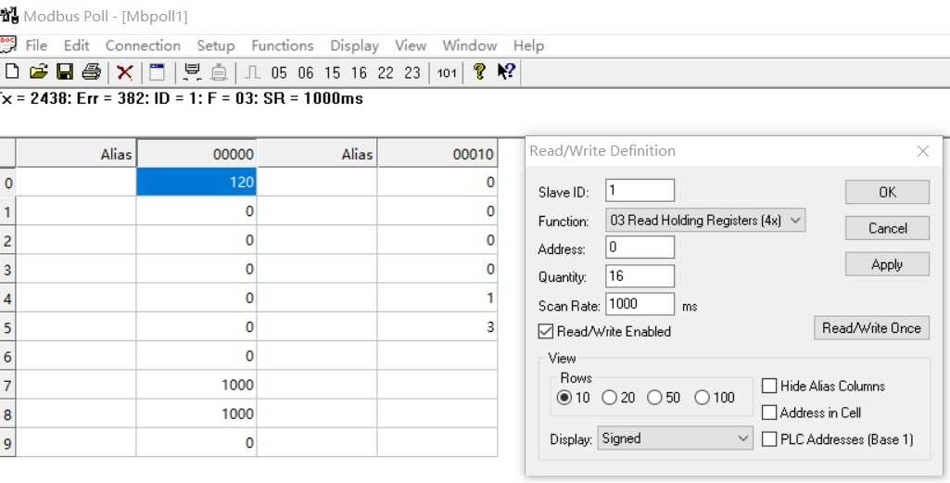

You can also use HyperTerminal serial input, as shown below

（Manually add CRC check）

